CIRCLE OAKS COUNTY WATER DISTRICT
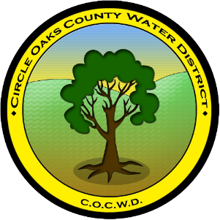
OFFICE OF THE BOARD OF DIRECTORS

380 Circle Oaks Drive
cocwd@circle-oaks.com
707 312 6629

AGENDA
REGULAR MEETING OF THE BOARD OF DIRECTORS
JED WELSH – PRESIDENT, RON TAMARISK – VICE-PRESIDENT, LESLIE ELLISON – DIRECTOR, DR. CHERYL LYNN DE WERFF – DIRECTOR, MELISA D. GUILLEN – DIRECTOR, PAUL QUARNERI – DISTRICT MANAGER, THOMAS MILLER – DISTRICT OPERATOR, ROBIN VAN HONK – DISTRICT SECRETARY
May 13th, 2026 6:00pm

- CALL TO ORDER
- MINUTES
- PUBLIC COMMENT
- DISTRICT MANAGER’S WRITTEN REPORT & FINANCIALS
- DISTRICT OPERATOR’S WRITTEN REPORT
- BOARD DISCUSSION ITEMS:
  - OUTREACH POLICY & Community Education on Small Water/Sewer District Awareness
  - Rooftop Sprinklers during fire-discussion with attorney
  - 2026-2027 Budget
- ACTION ITEMS:
  - Horizontal Drilling Quote
- DISTRICT SECRETARY’S CONFIRMATION OF FUTURE AGENDA ITEMS
- ADJOURNMENT
- CLOSED SESSION-NONE

