CIRCLE OAKS COUNTY WATER DISTRICT
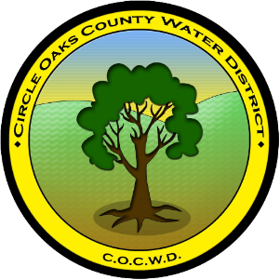
OFFICE OF THE BOARD OF DIRECTORS

380 Circle Oaks Drive
cocwd@circle-oaks.com
707 312 6629

AGENDA
NO MEETING-NO QUORUM
REGULAR MEETING OF THE BOARD OF DIRECTORS
JED WELSH – PRESIDENT, RON TAMARISK – VICE-PRESIDENT, LESLIE ELLISON – DIRECTOR, DR. CHERYL LYNN DE WERFF – DIRECTOR, MELISA D. GUILLEN – DIRECTOR, PAUL QUARNERI – DISTRICT MANAGER, THOMAS MILLER – DISTRICT OPERATOR, ROBIN VAN HONK – DISTRICT SECRETARY
FEBRUARY 11th, 2026 6:00pm

- CALL TO ORDER
- MINUTES
- PUBLIC COMMENT
- DISTRICT MANAGER’S WRITTEN REPORT & FINANCIALS
- DISTRICT OPERATOR’S WRITTEN REPORT
- BOARD DISCUSSION ITEMS
  - Firewise Beacon Box Sponsorship
  - Non-compliance Sewer Repair Charges Terms and Conditions
  - Shared water lines
  - Water Shortage Plan
  - OUTREACH POLICY & Community Education on Small Water/Sewer District Awareness
- ACTION ITEMS
- DISTRICT SECRETARY’S CONFIRMATION OF FUTURE AGENDA ITEMS
- ADJOURNMENT
- CLOSED SESSION-NONE

